**CERTIFICATE**

This is to certify that the report entitled **“COADING AND MANUFACTURING OF KONKURE-M MISSILE COMPONENT (COVER)”** has been submitted by **SESHABATTAR VENKATA SEETARAMAPPA SUDARSHAN,** student of VIGNANA BHARATHI INSTUTION OF TECHONOLOG, Ghatkesar of mechanical department under the guidance of

**ACKNOLOGEMENT**

The success and outcome of this project required a lot of guidance and assistance from project work. Whatever I have done is only due to such guidance and assistance and I would not forget to thank them.

I respect and thank **Mr. JAYARAJU** for providing me all support which made me complete the project on time, I am extremely grateful to him for providing such guidance through he had schedule managing the section. And **Mr. VENKATESHWAR** the manager for going us an opportunity to do the project work in **BHARAT DYNAMICS LIMITED.**

My sincere thanks to **G. PRANATHI**, Asst. professor and head of the department, mechanical engineering, **Dr. G. POSHAL**., Internship and implant training coordinator, for their constant encouragement to carry out the project work.

I am thankful and fortunate enough to get constant encouragement, support and guidance from all staff of the industry which helped me in successfully completing my project work

**ABSTRACT**

Missile defense system is a type of missile defense intended to shield a country against incoming missiles, such as international ballistic missile or another ballistic missile. India, United States, Russia, France, I and China had all developed missile defense system. To manufacture such a crucial missile or its components are very precision and accurate manufacturing methods is necessary. In our study we have found that only CNC technology will meet those requirements.

As of our project for machining the cylindrical grooves on **KONKU-M** missile **FRAME** component is achieved by selecting apt CNC machine to meet the quality finish requirements. To attain those requirements CNC 5 axis milling machine is choose for better accuracy and precession. To achieve our desire operation on missile component we have undergone the significant process likely development of fixtures which includes the good support holding device, development of CNC program to achieve the operation by giving moment to tool.

By having these three procedures any operation can be achieved as of requirement. Hence, we can generate cylindrical groove finish on the **KONKURS-M** missile **FRAME** component with accurate results.

**INDEX**

|  |  |  |
| --- | --- | --- |
| S .NO/FIGURE NO. | DESCRIPTION | PAGE .NO |
| 1. | **CERTIFICATE** | **1** |
| 2. | **ACKANOLOGEMENT** | **2** |
| 3. | **ABSTRACT** | **3** |
| 4. | **INDEX** | **4** |
| 5. | **APPENDIX-I** | **5** |
| 6. | **APPENDIX-II** | **8** |
| 7. | **INTRODUTION OF BDL** | **9** |
| 8. | **KONKURS-M-MISSILE** | **13** |
| 9. | **TYPE OF CNC MACHINES** | **16** |
| 10. | **TOOLS** | **18** |
| 11. | **PREQUISTES FOR CNC** | **32** |
| 12. | **G-CODES** | **34** |
| 13. | **M-CODES** | **35** |
| 14. | **CNC CYCLES** | **37** |
| 15. | **PROCESS PLAN** | **39** |
| 16. | **MANUFACTURING PROCESS FORKONKURCOVER** |  |
|  | 1. **TURNING** | **42** |
|  | 1. **DRILLING** | **50** |
|  | 1. **MILLING** | **52** |
| 17. | **WORK DONR(PICTURES)** |  |
| 18. | **DECLERATION** | **58** |
| 19. | **COUNTER BORE DRILL BIT** | **59** |
|  |  |  |

**APPENDIX-I**

**LIST OF FIGURES:**

|  |  |  |
| --- | --- | --- |
| S .NO/FIGURE NO. | DESCRIPTION | PAGE .NO |
| 1. | **BDL LOGO** | **10** |
| 2. | **AGNI** | **13** |
| 3. | **MILLAN** | **13** |
| 4. | **AKASH** | **13** |
| 5. | **KONKURS** | **13** |
| 6. | **MISSILE KONKUR** | **14** |
| 7. | **TURNING TOOL** | **19** |
| 8. | **BORING TOOL** | **19** |
| 9. | **CHAMFERING TOOL** | **20** |
| 10. | **PARTING TOOL** | **20** |
| 11. | **ROUGH ENDING MILL CUTTER** | **21** |
| 12. | **SLAB MILL CUTTER** | **21** |
| 13. | **END MILL CUTTER** | **22** |
| 14. | **COLLET CHUCK** | **23** |
| 15. | **END MILL HOLDER** | **24** |
|  |  |  |
| 16. | **HYDROLIC MILL HOLDER** | **24** |
| 17. | **MILLING CHUCK** | **25** |
| 18. | **SHELL MILL HOLDER** | **25** |
| 19. | **HEAT SHRINK** | **26** |
| 20. | **TWIST DRILL** | **27** |
| 21 | **COUNTER BORE DRILL BIT** | **27** |
| 22. | **COUNTER SINK DRILL BIT** | **28** |
| 23. | **NOMENCLATURE FOR DRILL BIT** | **28** |
| 24. | **TURINING INSERT SHAPE.A** | **29** |
| 25. | **TURNING INSERT SHAPE. B** | **29** |
| 26. | **TURINING INSERT TYPE** | **30** |
| 27. | **TURNING INSERT SIZE** | **31** |
| 28. | **TURNING INSERT NOSE RADIUS** | **32** |
| 29. | **BACKLASH** | **33** |
| 30 | **CARTESIAN COORDINATE SYSTEM** | **34** |
| 31. | **STEPS IN PLANING PROCESS** | **42** |
| 32. | **2 AXIS TURING CNC** | **43** |
| 33. | **COMPONENT DESIGN** | **44** |
| 34. | **4 AXIS CNC** | **51** |
| 35. | **5 AXIS MILLING CNC** | **53** |
| 36. | **CATIA DESIGN**  **INITIAL COMPONENT TO FINAL PRODUCT** | **58** |
|  |  |  |

**APPENDIX-II**

**LIST OF TABLES:**

|  |  |  |
| --- | --- | --- |
| S. No | DESCRIPTION | PAGE. No |
| 1. | **SERVICE HISTORY OF KONKURS MISSILE** | **14** |
| 2. | **PRODUCTION HISTORY OF KOONKURS MISSILE** | **14** |
| 3. | **SPECIFICATION OF KONKURS MISSILE** | **15** |
|  |  |  |
| 4. | **G&M-CODES** | **34-36** |

1. **INTRODUCTION**



Figure 1

**1.1 HISTORY OF BDL:**

India began to develop indigenous missiles through the [Integrated Guided Missile Development Program](https://en.wikipedia.org/wiki/Integrated_Guided_Missile_Development_Programme) (IGMDP), which gave BDL an opportunity –to be closely involved with the program wherein it was identified as the Prime Production Agency. This opened a plethora of opportunities to assimilate advanced manufacturing and program management technologies and skills. Responding to the Concurrent Engineering Approaches adopted by DRDO in IGMDP, BDL was seen as a reliable and trustworthy ally, and resulted in the induction of India's first state-of- the-art Surface-to-Surface Missile Prithvi. BDL has delivered Prithvi to the three services as per requirements. BDL has forayed into the field of underwater weapon systems and air-to-air missiles and associated equipment with technology support from DRDO and other players in this domain.

**1.2 OPERATIONS**

BDL has been consistently incurring profits and has been nominated as a Mini Ratna – Category-I Company by the [Government of India](https://en.wikipedia.org/wiki/Government_of_India). Showing steady progress in its operations over the years, BDL achieved a record sales turnover of ₹10.75 billion in 2012–13. BDL has orders worth over ₹180 billion. Keeping pace with the modernization of the [Indian Armed Forces](https://en.wikipedia.org/wiki/Indian_Armed_Forces), BDL is poised to enter new avenues of manufacturing covering a wide range of weapon systems such as: Surface to Air Missiles, Air Defense Systems, Heavy Weight Torpedoes, Air to Air Missiles, making it a defense equipment manufacturer. BDL has also entered into the arena of refurbishment of old missiles.

**1.3 OBJECTIVES OF BDL:**

**Bharat Dynamics Limited** (**BDL**) is one of [India](https://en.wikipedia.org/wiki/India)'s manufacturers of [ammunitions](https://en.wikipedia.org/wiki/Ammunition) and [missile](https://en.wikipedia.org/wiki/Missile) systems. It was founded in 1970 in [Hyderabad](https://en.wikipedia.org/wiki/Hyderabad), [Telangana](https://en.wikipedia.org/wiki/Telangana). BDL was established in the year 1970 to be a manufacturing base for guided weapon systems. Begun with a pool of engineers drawn from [DRDO](https://en.wikipedia.org/wiki/DRDO) and aerospace industries, BDL began by producing a first generation anti-tank guided missile - the French SS11B1. This product was a culmination of a license agreement the [Government of India](https://en.wikipedia.org/wiki/Government_of_India) entered into with [Aerospatiale](https://en.wikipedia.org/wiki/Aerospatiale). BDL has three manufacturing units, located at [Kanchan Bagh](https://en.wikipedia.org/wiki/Lab_quarters), Hyderabad, Telangana; Bhanur, [Medak district](https://en.wikipedia.org/wiki/Medak_district), Telangana and [Visakhapatnam](https://en.wikipedia.org/wiki/Visakhapatnam), Andhra Pradesh.

**1.4 INDIGENOUS MISSILES:**

[**Agni**](https://en.wikipedia.org/wiki/Agni_(missile))

In 1998, BDL produced [Agni-I](https://en.wikipedia.org/wiki/Agni-I) was inducted into the Indian Armed Forces. BDL also manufactures other missiles and systems for the Indian Armed Forces

[**Akash**](https://en.wikipedia.org/wiki/Akash_(missile))

Akash is a medium-range [surface-to-air missile](https://en.wikipedia.org/wiki/Surface-to-air_missile) defense system developed by the [Defense Research and Development Organization](https://en.wikipedia.org/wiki/Defence_Research_and_Development_Organisation) ([DRDO](https://en.wikipedia.org/wiki/DRDO)), and supported by [Ordnance Factories Board](https://en.wikipedia.org/wiki/Ordnance_Factories_Board) and [Bharat Electronics](https://en.wikipedia.org/wiki/Bharat_Electronics) (BEL) in [India](https://en.wikipedia.org/wiki/India). The missile system can target aircraft up to 30 km away, at altitudes up to 18,000 m. A pre-fragmented warhead could potentially give the missile the capability to destroy both aircraft and warheads from ballistic missiles. It is in operational service with the [Indian Army](https://en.wikipedia.org/wiki/Indian_Army) and the [Indian Air Force](https://en.wikipedia.org/wiki/Indian_Air_Force).

* Advanced Light Weight [Torpedo](https://en.wikipedia.org/wiki/Torpedo)
* It can be launched from a Ship, a Helicopter, submarine as well and available as both wars shot / exercise modes. Homing can be passive / active / mixed modes. Multiple search pattern capability.
* Counter Measures Dispensing Systems
* Counter Measures Dispensing System (CMDS) is chaff and flare dispensing system. CMDS is an airborne defensive system providing self-protection to the aircraft by passive ECM against radar guided & IR seeking, air & ground launched missiles. Protection to the aircraft is achieved by misguiding the missiles by dispensing of chaff and/or flare payloads.

[**MILAN**](https://en.wikipedia.org/wiki/MILAN) **2T**

This is a second generation, semi-automatic, tube launched optically tracked missiles with tandem warhead.

[**Konkurs**](https://en.wikipedia.org/wiki/Konkurs) **– M**

This is a second generation, semi-automatic, antitank, tube launched, optically tracked, wire guided and aero-dynamically controlled missile. It is designed to destroy moving and stationary armored targets with Explosives Reactive Armors at a range of 75 to 4000 meters.

* Salient Features : Can be launched either from [BMP-2](https://en.wikipedia.org/wiki/BMP-2) or from ground launcher. Tandem Warhead Simple in operation and immune to Electronic Counter measures High hit and kills probability Portable and Para droppable. Hermetically sealed ensuring long storage life.

**Invar**

Invar is weapon fired from the Gun barrel of [T-90](https://en.wikipedia.org/wiki/T-90) Tank. The missile has a semi-automatic control system, tele-orienting in the laser beam. This is high velocity jamming immune missile with tandem warhead designed to defeat explosive [reactive armor](https://en.wikipedia.org/wiki/Reactive_armour). Intended to destroy stationary and moving targets with speeds up to 70 km/hr.

DRDO (Design)

BDL (Corporate office)

Method &tool planning

Material management

Production planning and control

Electro plating &finishing

Assemble section

Store department

Quality control

Figure 2

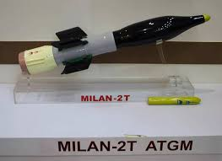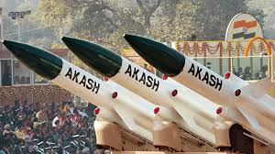

Figure 3 Figure 4

Figure 5

1. **INTRODUCTION**

**FOR**

**MISSILE KONKURE -M**

Figure 6

**2.1 DEVELOPMENT**

The 9M113 Konkurs was developed by the [Tula Machinery Design Bureau (Tula KBP)](https://en.wikipedia.org/wiki/KBP_Instrument_Design_Bureau). Development began with the aim of producing the next generation of [SACLOS](https://en.wikipedia.org/wiki/Semi-automatic_command_to_line_of_sight) anti-tank missiles, for use in both the man-portable role and the tank destroyer role. The 9M113 Konkurs was developed alongside the [9M111](https://en.wikipedia.org/wiki/9K111_Fagot).The missiles use similar technology, differing only in size. The original 9M113 with a single-charge warhead can penetrate 600 mm of [rolled homogeneous armor](https://en.wikipedia.org/wiki/Rolled_homogeneous_armor) (RHA).

**2.2 DESCRIPTION**

The missile is designed to be fired from vehicles, although it can also be fired from the later models of [9M111](https://en.wikipedia.org/wiki/9K111_Fagot) launchers. It is an integral part of the [BMP-2](https://en.wikipedia.org/wiki/BMP-2), [BMD-2](https://en.wikipedia.org/wiki/BMD-2) and [BRDM-2](https://en.wikipedia.org/wiki/BRDM-2) vehicles. The missile is stored and carried in a fiberglass container/launch tube. The system uses a gas generator to push the missile out of the launch tube. The gas also exits from the rear of the launch tube in a similar manner to a [recoilless rifle](https://en.wikipedia.org/wiki/Recoilless_rifle). The missile leaves the launch tube at 80 meters per second and is quickly accelerated to 200 meters per second by its solid fuel motor. This initial high speed reduces the missile's dead zone, since it can be launched directly at the target, rather than in an upward arc. In flight, the missile spins at between five and seven revolutions per second.

The launcher tracks the position of an incandescent [infrared](https://en.wikipedia.org/wiki/Infrared) bulb on the back of the missile relative to the target and transmits appropriate commands to the missile via a thin wire that trails behind the missile. The system has an alarm that activates when it detects jamming from a system like [Shtora](https://en.wikipedia.org/wiki/Shtora). The operator can then take manual control, reducing the missile to [MCLOS](https://en.wikipedia.org/wiki/Manual_command_to_line_of_sight). The [SACLOS](https://en.wikipedia.org/wiki/Semi-automatic_command_to_line_of_sight) guidance system has many benefits over MCLOS. The system's accuracy is quoted in some sources as 90%, though its performance is probably comparable to the [BGM-71 TOW](https://en.wikipedia.org/wiki/BGM-71_TOW) or later SACLOS versions of the [9K11 Malyutka](https://en.wikipedia.org/wiki/9K11_Malyutka).

**2.3 MISSILE SPECIFICATIONS**

**2.3.1 SERVICE HISTORY**

|  |  |
| --- | --- |
| **Type** | [Anti-tank missile](https://en.wikipedia.org/wiki/Anti-tank_missile) |
| **Place of origin** | Soviet Union |
| **In service** | 1974–present |
| **Used by** | [See operators](https://en.wikipedia.org/wiki/9M113_Konkurs#Operators) |
| **Wars** | [Syrian Civil War](https://en.wikipedia.org/wiki/Syrian_Civil_War)  [Iraqi Civil War](https://en.wikipedia.org/wiki/Iraqi_Civil_War_(2014%E2%80%932017)) |

**1.3.2 PRODUCTION HISTORY**

|  |  |
| --- | --- |
| **Designed** | 1970 |
| **Manufacturer** | [Tula Machinery Design Bureau (Tula KBP)](https://en.wikipedia.org/wiki/KBP_Instrument_Design_Bureau) – [Tulsky Oruzheiny Zavod](https://en.wikipedia.org/wiki/Tulsky_Oruzheiny_Zavod) |
| **Variants** | 9M113M |

**2.3.3 SPECIFICATIONS**

|  |  |
| --- | --- |
| **Mass** | 14.6 kg (32 lb) (Missile weight)  22.5 kg (50 lb) (9P135 launching post) |
| **Length** | 1,150 mm (45 in) 875 mm (34.4 in) without gas generator |
| **Diameter** | 135 mm (5.3 in) |
| **Warhead** | 2.7 kg (6.0 lb) 9N131 [HEAT](https://en.wikipedia.org/wiki/High-explosive_anti-tank_warhead) |
| **Detonation mechanism** | Contact |
| **Engine** | Solid-fuel rocket |
| **Wingspan** | 468 mm (18.4 in) |
| **Operational range** | 70 m (230 ft) to 4 km (2.5 mi) |
| **Speed** | 208 m/s (680 ft/s) |
| **Guidance system** | [Wire-guided](https://en.wikipedia.org/wiki/Wire-guided_missile)[SACLOS](https://en.wikipedia.org/wiki/Semi-automatic_command_to_line_of_sight) |
| **Steering system** | Two control surfaces |
| **Launch platform** | Individual, vehicle |

1. **TYPES OF CNC MACHINES**

**3.1 CNC Milling Machine**

A CNC factory is a machine that uses computer controls to cut different materials. Factories can decipher projects of numbers and letters keeping in mind the end goal to move the axle in different ways. Many factories utilize what is known as G-code – an institutionalized programming dialect perceived by most CNC machines.

**3.2 CNC Lathe Machine**

A machine is a CNC machine that capacities to cut workpieces as they are turned. CNC lathe can make exact cuts rapidly by utilizing different apparatuses. These [CNC machining](https://mdaltd.ca/cnc-machining/) are very successful in the exactness they offer contrasted with a manual lathe.

**3.3 CNC Routers**

A CNC router is like a CNC process. It accompanies the capacity to utilize PC numerical control to course instrument ways that empower the machine to work. CNC router diminish waste and increment efficiency, creating different things in a considerably shorter measure of time than utilizing different machines.

**3.4 CNC Plasma Cutters**

The procedure of plasma cutting includes the cutting of a material utilizing a plasma burn. This strategy is most ordinarily used to cut overwhelming materials, for example, steel and different types of metal.

**3.5 CNC Electric Discharge Machines**

Electric discharge machining, or EDM for short, includes making a shape inside a specific material by utilizing electrical releases or starts. The material is expelled from a workpiece by a progression of repeating electrical releases between two anodes. These anodes are isolated by a dielectric liquid, which regularly gets an electric voltage.

**3.6 DRILLING MACHINES**

CNC drills are highly advanced drilling machines where the speed of the drill and the depth to be drilled is handled by highly sophisticated computer programs.

**3.7 TYPES OF CNC MACHINE CONTROL**

* **FANUC CONTROL**
* **SIEMENS**

**4. TOOLS**

**4.1 TYPES OF TURNING TOOLS:**

**4.1.1 Facing Turning Tool**

A facing turning tool is going to be an essential part of your lathe experience. You need to have access to this tool when you want to shorten low long the stock is on an item. It is also capable of making a smaller diameter, so you can see how this is going to come in handy for various projects

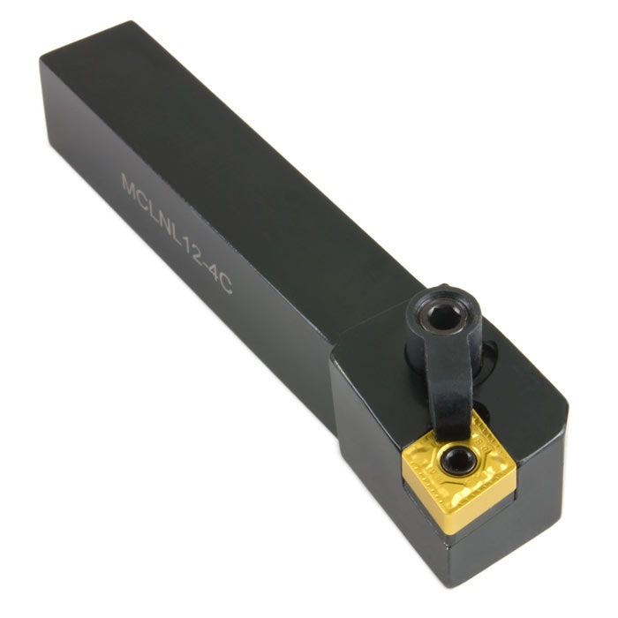

Figure 7

**4.1.2 Boring Tool**

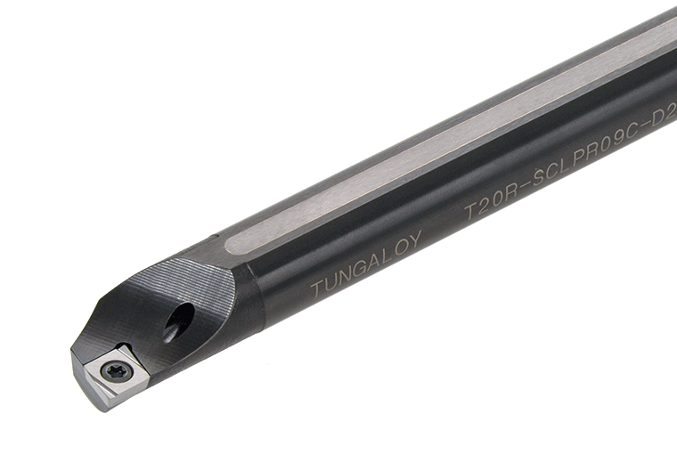 Boring tool will be useful when you need make a hole bigger than it already is. If you need to make room for large screws in a piece you are building, or if you want a larger hole for any other reason, this is going to be what you turn to. A boring bar can easily bore into the hole that is present and will widen the area for you. It is important to understand that there does need to be a hole already present for this tool to work properly.

Figure 8

**4.1.3 Chamfering Tool**

Chamfering tools are often used when someone needs to break off an edge on a piece. It is also useful for making a chamfer on the stock's edge, so you will be able to make this job a lot easier by owning one of these tools. The drill bits on your chamfering tool should be heavy duty in order to perform their job well.

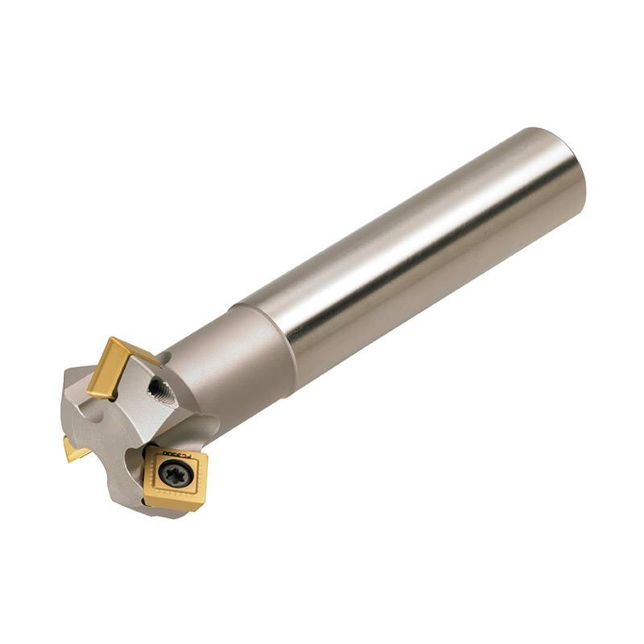

Figure 9

**4.1.4 Parting Tool**

Parting tools are among the most essential types of tools that you can purchase for your lathe No matter what type of work you plan on doing with your lathe, it is likely that you will need one of these at some point. They are used to shorten things or cut off certain sections of stock. This will be crucial when you're trying to make everything fit.

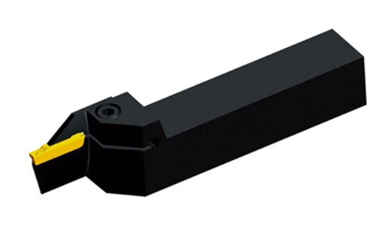

Figure 10

**4.2 Types of Milling Tools**

**4.2.1 Roughing End Mill Cutter**

This type of cutter is used when you have to remove more amount of material from the work piece. By using roughing end mills, we obtain a rough surface finishing. Roughing end mills are also famous as "rippa" cutters. They are more beneficial commercially and are used in various industrial applications

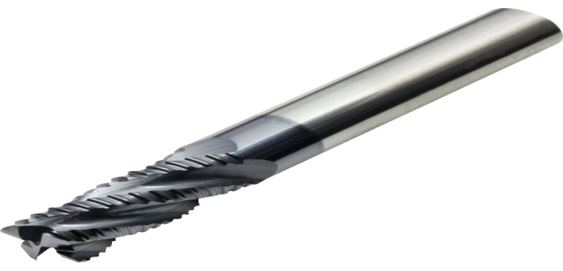

Figure 11

**4.2.2 Slab Mill Cutter**

Slab mills are used either by themselves or in gang milling operations on manual horizontal or universal milling machines to machine large broad surfaces quickly. They have been superseded by the use of cemented carbide-tipped face mills which are then used in vertical mills or machining centers

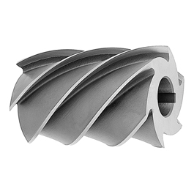

Figure 12

**4.2.3 End Mill Cutter**

These types of milling cutters have the cutting teeth on the both sides. We use end mill more in the vertical milling processes. High speed steel or the cemented carbide is used to create end mills. High speed steel is also called as HS or HSS the high-speed steel doesn't lose its hardness when the temperature increases. Hence, due to better hardness the high-speed steel is used to make end mills. The end mills are mostly used in plunging, tracer milling face milling, etc.

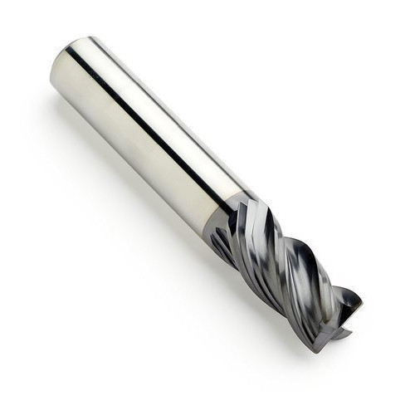

Figure 13

**4.3 Types of Milling Tool Holders**

A tool holder is a machining component that holds the end mill in place. Its purpose is to hold the tool in place as precisely and firmly as possible, as a barely perceptible increase in run out can ruin your project or break your cutting tool different types of holders have varying levels of run out and balance. There is also variation in their lifespan and durability. Another important factor to consider when picking a CNC tool holder is the time it takes to change end mills, as it directly impacts your bottom line.

**4.3.1 Run-out Accuracy/Concentricity**

Holders should be selected based on their ability to hold the tool concentric to spindle rotation. This normally results in tools that are friction driven, such as collet chucks, shrink fit holders, power milling chucks, etc. When selecting a friction drive holder over a positive drive such as a side lock end mill holder, you are sacrificing positive drive for better run out accuracy and balance

**4.3.2 Balance**

As spindle speeds are increased in a given application, the more important the balance of the holder becomes. The effect that a lack of balance will have on cutting operation is relative to the spot forces de the higher the cutting forces the less effect balance will have on the overall operation of the machine tool Under most circumstances a pre-balanced holder all that is required to Balanced machining condition If you select a highly balanced tool holder but with poor concentricity, the effective cutting force from the outside cutting edge w be detrimental to the operation

* **Collet Chuck**

A collet chuck includes a chuck body hand unit. They are very versatile since different collet sizes can be used in one holder allowing for different size tools being held. They come in a variety of shank and type

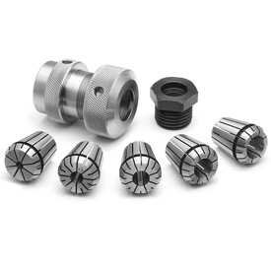

Figure 14

* **End Mill Holder**

For heavy machining. Used to hold end mill End mill holders hold cutting tools with more rigidity than collets. They are available in Weldon type for using tools with Weldon flats

* 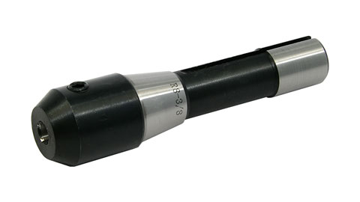**Hydraulic Tool Holder**

Figure 15

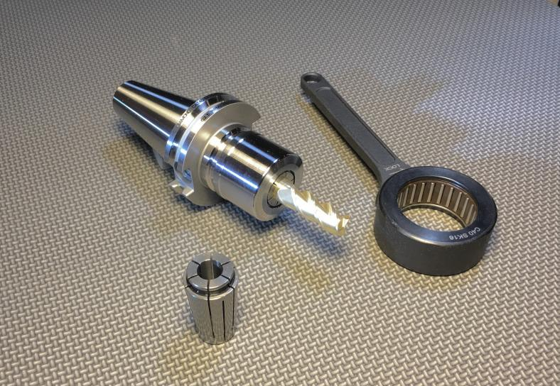Hydraulic tool holders are the easiest holders for most operators to use and should be applied in close tolerance operations or where expensive round tools are being used and maximizing tool life is important.

Figure 16

* **Milling Chuck**

For precision in moderate and lower speed milling and nominal drilling applications. Very good concentricity and good side load capability. Movable large clamping nut restricts the balance and centrifugal force capability, limiting the speed to 8,000 to 12,000 rpm.

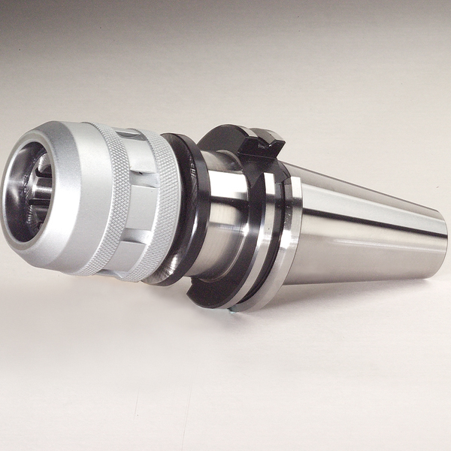

Figure 17

* **Shell Mill Holder**

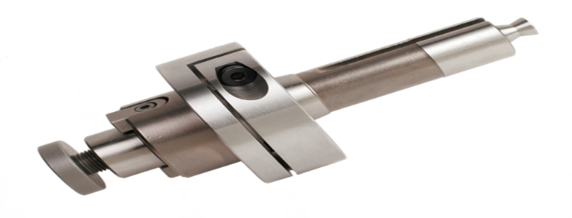For holding milling cutters that utilize the American National Standard mount for Shell Mills. Modern cutters are commonly index able. Shell mill lock screw and socket head cap screws are commonly used depending on milling cutter manufacturer's specification. Either or both are provided with each holder depending on the size.

Figure 18

* **Shrink Fit Holder (Heat Shrink):**

For nominal size drilling with higher speed and high feed milling applications. Excellent concentricity and excellent balance. No moving features, and thin nose diameters, make it exceptional for high speed machining Safe operating speeds are extremely high out mite impact from centrifugal forces. A Heat Shrink machine should be purchased to me optimal performance

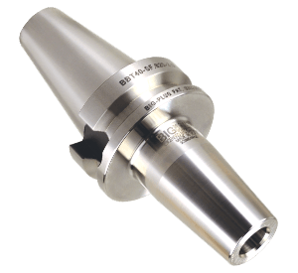

Figure 19

**4.4 Types of Drills: -**

* **Twist Drills**

Twist drill bits are the most common type of drill bit and are used for everyday drilling in all types of material. They are also the most confusing due to the sheer number of sizes, tip, and material specifications.

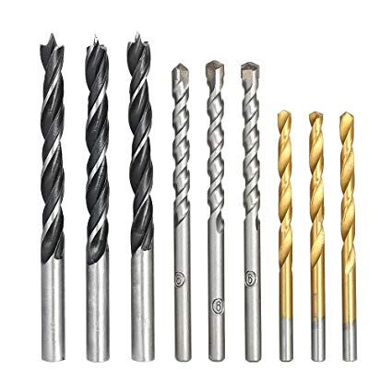

Figure 20

* **Counter bore Drill Bits**

Counter bore drill bits create a flat bottom blind hole with a smaller diameter Centre hole that penetrates through the material. The purpose of a counter bore is usually to conceal the fastener head (by covering the hole) or provide a recess to prevent the fastener from protruding above the surface of the material being drilled. Counter bores on our site are designed for use in wood or plastics and are not intended for counter boring steel.

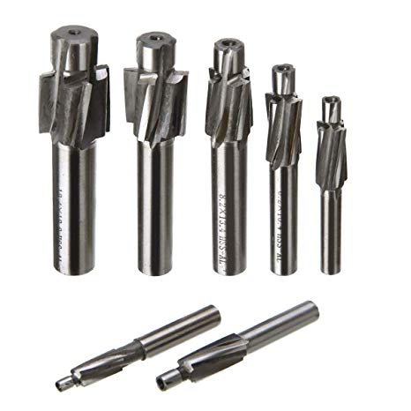

Figure 21

* **Countersink drill bits**

Countersink drill bits create a tapered surface hole with a smaller Centre hole that penetrates through the material(some are available without a Centre drill for countersinking exiting hole).the purpose of a countersink is to allow a tapered head fastener to sit flush with the surface of the material. Countersinks on our site are designed for use in wood or plastics and are intended for counter boring steel.

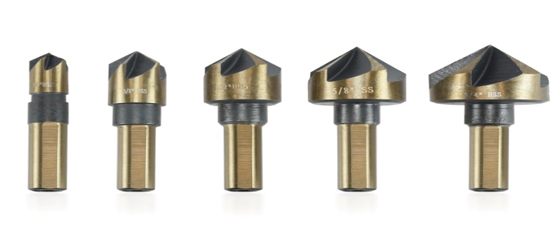

Figure 22

**4.5 General Turning Insert Nomenclature for CNC**

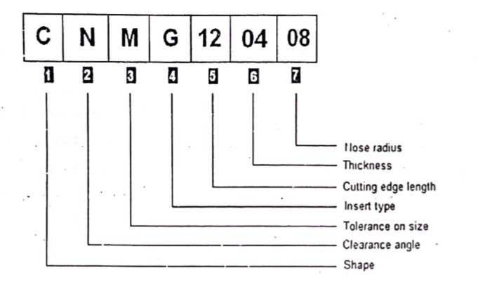 General turning inserts come in variety of shapes and sizes One thing is important remember and understand is that every turning insert has a nomenclature ate will These general turning inserts nomenclature tells us lot about these general timing we The turning inserts nomenclature is a list of some letters and numbers, but lot more da hidden inside them

Figure 23

**4.6 Turning Insert Shape**

The first letter in general turning insert nomenclature tells us about the general turning insert shape, turning inserts shape codes are like C, D, K, R, S, T, V, W. Most of these codes surely express the turning insert shape like

C-C Shape Turning Insert

D=D Shape Turning Insert

K=K Shape Turning Insert

R=Round Turning Insert

S=Square Tubing Insert

T-Triangle Turning Insert

V=V Shape Turning Insert

Figure 24

W-W Shape Turning Insert

Figure 25

**4.7 Turning Insert Clearance Angle**

The second letter in general turning insert nomenclature tells us about the turning insert

Clearance angle.

B=Turning Insert with 5 clearance angle turning Insert with clearance angle

E=Turning Insert with 20 clearance angles

N=Turning Insert with 0clearance angle

P= Turning Insert with 11 clearance angles

Turning insert clearance angle plays a big role while choosing an smart for internal machining or boring small components, because if not properly chosen the insert bottom corner might rub with the component which will give poor machining On the other hand turning insert with 0 clearance angle is mostly used for rough machining

**4.9 Turning Insert Tolerances**

The third letter of general turning insert nomenclature tells us about the turning insert tolerances. These are the turning insert tolerances in different insert sizes, like the tolerance in turning insert length, height etc. I personally think that they are not of any use for a CNC machinist because these tolerances are minor

**4.10 Turning Insert Type**

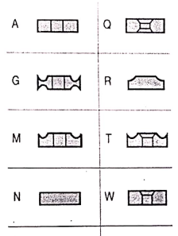The fourth letter of general turning insert nomenclature tells us about the turning insert hole shape and chip breaker type

A=Turning insert with Cylindrical hole

G=Turning insert with Cylindrical hole and Double-Sided Chip breaker

M=Turning insert with Cylindrical hole and Single-Sided Chip breaker

Figure 26

N=Turning insert with no hole and no Chip breaker

P = Turning insert with Cylindrical hole and Hi-Double-Positive Chip

Q = Turning insert with 40-60° Double Countersink Hole

R=Turning insert with no-hole and Single-Sided Chip breaker

T = Turning insert with 40-60° Double Countersink Single-sided Chip breaker

W=Turning insert with 40-60° double countersink

X=Turning insert with Special

**4.11 Turning insert size**

The numeric value of general turning insert tells us the cutting-edge length of the turning insert.

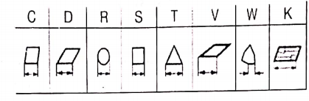

Figure 27

**4.12 Turning insert thickness**

Thickness is the form the insert to the top of the cutting edge

**4.13 Turning insert nose radius**

This numeric value of general turning insert tells us about the nose radius of the turning insert.

Code = Radius Value (mm)

00 = Sharp cutting corner

Figure 28

X0 = 0.04

04 = 0.4

08 =0.8

12 =1.2

16 =1.6

24 =2.4

32 =3.2

M0=Inscribed circle metric (for round inserts)

**5.PREQUISITES OF CNC**

* **NUMERICAL PRECISION AND EQUIPMENT BACKLASH**
* **POSITIONING CONTROL SYSTEM**
* **CARTESIAN CO-ORDINATE SYSTEM**

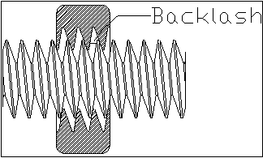**5.1 NUMERICAL PRECISION AND EQUIPMENT BACKLASH:**

Figure 29

Within the numerical systems of CNC programming it is possible for the code generator to assume that the controlled mechanism is always perfectly accurate, or that precision tolerances are identical for all cutting or movement directions. This is not always a true condition of CNC tools. CNC tools with a large amount of mechanical [backlash](https://en.wikipedia.org/wiki/Backlash_(engineering)) can still be highly precise if the drive or cutting mechanism is only driven so as to apply cutting force from one direction, and all driving systems are pressed tightly together in that one cutting direction. However, a CNC device with high backlash and a dull cutting tool can lead to cutter chatter and possible workpiece gouging. Backlash also affects precision of some operations involving axis movement reversals during cutting, such as the milling of a circle, where axis motion is sinusoidal. However, this can be compensated for if the amount of backlash is precisely known by linear encoders or manual measurement.

The high backlash mechanism itself is not necessarily relied on to be repeatedly precise for the cutting process, but some other reference object or precision surface may be used to zero the mechanism, by tightly applying pressure against the reference and setting that as the zero reference for all following CNC-encoded motions. This is similar to the manual machine tool method of clamping a micrometer onto a reference beam and adjusting the Venire dial to zero using that object as the reference.

**5.2 POSITIONING CONTROL SYSTEM**

In numerical control systems, the position of the tool is defined by a set of instructions called the program. Positioning control is handled by means of either an open loop or a closed loop system. In an open loop system, communication takes place in one direction only: from the controller to the motor. In a closed loop system, feedback is provided to the controller so that it can correct for errors in position, velocity, and acceleration, which can arise due to variations in load or temperature. Open loop systems are generally cheaper but less accurate. Stepper motors can be used in both types of systems, while servo motors can only be used in closed systems.

**5.3 CARTESIAN CO-ORDINATE SYSTEM**

The G & M code positions are all based on a three-dimensional Cartesian coordinate system. This system is a typical plane often seen in math’s when graphing. This system is required to map out the machine tool paths and any other kind of actions that need to happen in a specific coordinate. Absolute coordinates are what is generally used more commonly for machines and represent the (0,0,0) point on the plane. This point is set on the stock material in order to give a starting point or "home position" before starting the actual machining.

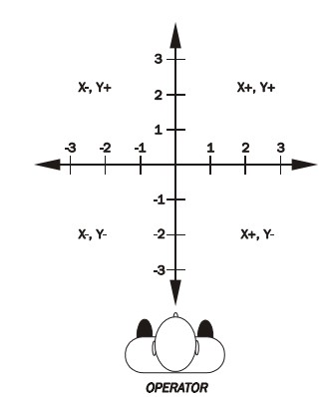

Figure 30

1. **G-CODE**

|  |  |
| --- | --- |
| **CODE** | **FUNCTION** |
| G00 | Rapid traverse |
| G01 | Linear interpolation |
| G02 | Circular interpolation CW |
| G03 | Circular interpolation CCW |
| G04 | Dwell |
| G05 | FADAL Non modal rapids |
| G15 | Turn polar coordinates off or return to Cartesian coordinates |
| G16 | Cartesian coordinates off |
| G17 | X Y plane selection |
| G18 | Z X plane selection |
| G19 | YZ plane selection |
| G20 | All dimensions in inches |
| G21 | All dimensions in mm |
| G27 | Reference point return check |
| G28 | Return to reference position |
| G29 | Return from reference point |
| G30 | 2nd, 3rd and 4th reference position return |
| G32 | Threading cycle |
| G33 | Threading cycle |
| G40 | Cutter compensation cancel |
| G41 | Cutter compensation left |
| G42 | Cutter compensation right |
| G43 | Tool length compensation + direction |
| G44 | Tool length compensation direction |
| G49 | Tool length compensation cancel |
| G50 | Reset all scale to 1 |
| G51 | Scale factor on |
| G52 | Local work shift for all coordinate system |
| G53 | Machine coordinate system selection |
| G54 | Work piece coordinate system I selection |
| G55 | Workpiece coordinate system 2 selection |
| G56 | Work piece coordinate system 3 selection |
| G57 | Workpiece coordinate system 4 selection |
| G58 | Workpiece coordinate system 5 selection |
| G59 | Workpiece coordinate system 6 selection |
| G61 | Exact stop check mode |
| G62 | Automatic corner override |
| G63 | Tapping mode |
| G64 | Best speed path |
| G65 | Custom macros simple call |
| G68 | Coordinate rotation |
| G69 | Coordinate rotation cancel |
| G73 | High speed drilling cycle |
| G74 | Left hand tapping cycle |
| G76 | Fine boring cycle |
| G80 | Canned cycle cancels |
| G81 | Simple Drilling cycle, spot boring cycle |
| G82 | Drilling cycle with dwell |
| G83 | Peck drilling cycle |
| G84 | Tapping cycle |
| G85 | Boring canned cycle, no dwell feed out |
| G86 | Boring canned cycle, spindle stop, rapid cut |
| G87 | Back boring cycle |
| G88 | Boring cycle, spindle stop, manual cut |
| G89 | Boring cycle, dwell feed out |
| G90 | Absolute Command |
| G91 | Increment command |
| G92 | Setting for work coordinate system or clamp at maximum spindle speed |
| G94 | Feed in mm per minute |
| G95 | Feed in mm per revolution |
| G96 | Constant cutting speed |
| G97 | Cancel G96 |
| G98 | Return to initial point in canned cycle |
| G99 | Return to R point in canned cycle |

**6.1 M-CODE**

|  |  |  |
| --- | --- | --- |
| **CODE** | **FUNCTION** | |
| M00 | Program stop | |
| M01 | Optional stop | |
| M02 | End of program | |
| M03 | Spindle ON (CW rotation) | |
| M04 | Spindle ON | |
| M05 | Spindle stop | |
| M06 | Tool change | |
| M07 | Mist coolant ON | |
| M08 | Flood coolant ON | |
| M09 | Coolant ON | |
| M10 | A-Axis locking | |
| M11 | A-Axis unlocking | |
| M17 | FADAL sub routine return | |
| M19 | Spindle oriented | |
| M20 | Axis locking | |
| M21 | Axis unlocking | |
| M29 | Rigid tapping mode ON, Fanuc controls | |
| M30 | End of the program, Rewind and Reset modes | |
| M97 | Hass-style sub program call | |
| M98 | Sub program call | |
| M99 | | Return from sub program |

1. **CNC CYCLES**

CNC programming cycles makes CNC programmer life easy here

* CNC programming cycles make our life easy.
* CNC programming cycles make program management easy.
* RepetitiveCNC program block is summed up in just one or two CNC programming blocks.
* Increase productivity.
* Shortens component machining time.
* Makes our CNC programs clutter free (without CNC canned cycle our program will be much longer).
* CNC programming cycles give better control over tool feed and depth of cut (you can vary depth of cut by just changing one parameter).
* Less memory usage (CNC programming cycles shortens CNC program length).
* Better component Finish and Increase in Tool Insert life (threading cycles on most CNC controls uses a technique in which CNC controls gradually decreases the depth of cut when they are near the required dimension).
* Makes CNC program debugging easy (short programs are easier to debug).

**7.1 TYPES OF CYCLES**

* **CANNED CYCLE (G72, G80)**
* **DRILLING CYCLE (G73, G81, G82, G83)**
* **THREADING CYCLE (G33)**
* **TAPPING CYCLE (G63, G74, G84)**
* **BORING CYCLE (G73, G81, G82, G83)**

**7.2 CANNED CYCLE:**

A canned cycle is a way of conveniently performing repetitive CNC machine operations. Canned cycles automate certain machining functions such as drilling, boring, threading, pocketing, etc... Canned cycles are so called because they allow a concise way to program a machine to produce a feature of a part.As canned cycles reduce the number of blocks in a program, the storage space occupied by the program is less and the programmer escapes the tedium of writing the same instructions again and again. This reduces the potential for errors, and locating any errors that do exist is easier in a shorter program. A canned cycle is also called as fixed cycle.

A canned cycle is used to simplify programming of a part. Canned cycles are defined for most common Z-axis repetitive operations such as drilling, tapping, and boring. Once selected, a canned cycle is active until canceled with the G80 code. There are six operations involved in every canned cycle:

* Positioning of X and Y axes (optional A, rotary axis).
* Rapid traverse to the reference plane.
* Drilling, boring, or tapping action.
* Operation at the bottom of the hole.
* Retraction to the reference plane.
* Rapid traverse to the initial starting point.

Canned cycle will only be executed in the Z-axis when positioning to a new X and/ or Y axis position after a canned cycle is selected. G98 and G99 are modal commands which change the way a canned cycle operates. G98 (default) will cause Z-axis to return to the initial starting point, and G99 will return Z-axis to the R (reference) plane after a cycle has been executed and positions to a new location to execute another cycle.

**8.PROCESS PLANNING**

Process planning is the act of transforming an engineering design into a work instruction to manufacture a physical product. Process planning for CNC machining is complex, due to the large requirement of data and information. This to a large extent but not entirely concerns manufacturing data, such as identification of operations, machines, tools, machining parameters, etc. Information about customer demands is also essential for performing effective process plans. Data must be evaluated and decided upon in order to create a process plan that meets requirements tobe able to reach optimal or near optimal machining operations, the use of various supports/aids is often necessary and desired. There are a wide variety of computer-aided tools on the market for process planning (and design), such as different CAD/CAM, CAPP (Computer-Aided Process Planning) and PLM (Product Lifecycle Management) solutions, that integrate essential company functions and automate manual labor. Despite this, process planning is still in many companies often characterized by a substantial part of manual work. The paper targets this issue by presenting a qualitative survey of six companies’ work with process planning of CNC machining. Earlier research through a quantitative survey highlighted some of the problems of process planning in the Swedish metal working industry Process planning work lacks clear management and companies only have vague knowledge about their process planning efficiency. This possibly comes as a consequence from a lack in use of methodologies and measurements of the process efficiency. Another questionnaire survey strengthened these assumptions, by showing a number of short comings in the measurement of process performance ingeneral and process planning performance in particularalso pointed to a large potential for process planningefficiencyimprovements through improved information management.

**8.1 Research scope**

This paper aims at highlighting the main strengths and deficiencies regarding process planning efficiency and working methodologies for typical CNC machining companies. The paper presents employed and potential future process planning aids in theory and practice for a number of companies. The main research question is to investigate a number of companies’ process planning automation level. This generated a set of sub-questions to answer.

**8.2 PROCESS PLANNING FOR CNC MACHINING**

Process planning is essentially the act of turning a set of specifications geometrical, technical, financial, logistical, environmental etc. into a document over how to manufacture a part. CNC machining is interesting to study since it encompasses many different parameters that must be managed in order to optimize the manufacture process. The main parameters include tool selection, fixturing machining data, tool path generation. The output from these parameters are manufacturing lead time, product quality, machine down time and overall economics. Altogether this makes CNC machining a challenging process to manage and optimize.

**8.3AUTOMATION LEVEL OF PROCESS PLANNING**

Creative work is difficult to automate. However, process planning includes work activities that are more routine, clerical and tedious (repeating calculations), hence more appropriate to initially focus on. These have been targeted in different ways for improvements Tool path generation, e.g. CAM software is directed towards automated tool path generation contra manual NC programming, where each trajectory, must be individually defined by the programmer; • Tool selection, automatic tool selection for different machining features and materials; • Efficiency of data, information and knowledge management; • Work instructions writing (e.g., templates, wizards, automatic generation)

**8.4 METHOD**

The research method is based on qualitative semi structured interviews with process planners. Each interview session was 1 to 3 hours, where a simple part model was used at the centre of discussions. The interviews were conducted on company sites and comprising 1 to 6 persons in each company. In order to be able to answer the research questions the process planning workflow was constructed for each company. This was carried out by using a set of predefined building blocks activity, computer aids, information and knowledge sourcethe company interviews were analyzed using a model of the automation level of process planning functions. The model focuses on the main value adding activities in of process planning This is a shorter list than the number of activities that any company carry out However, the five activities are the fundament of process planning, hence motivated to shortlist the activities. Each company is categorized according to the model, which gives an understanding for the studied companies’ present position regarding the automation level of process planning. The analysis model is based on theory regarding process planning and computer aids for process planning the results are presented in a radar chart, which describes the level of automation of process planning work

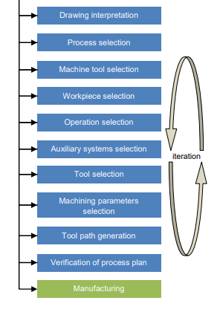**8.5 MAIN STEPS IN PROCESS PLANNING FOR CNC MACHINING**

Figure 31

* 1. **MANUFACTURING PROCESS FOR KONKURS-M COVER**

**9.1 TURNING**  
**9.1.1 CNC Turning Machine Specifications**:

* Make & Model EMCO TURN 500
* Axis 2 Axis; X=310; Z=1060
* Control system SINUMERIK 810D
* Memory capacity 1.984 MB
* Automatic tool changer (ATC) 12 (max. capacity)
* Machine code 64005
* Machine cost 1.02 Cores
* Cycle time 10minutes

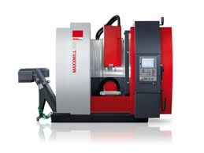

Figure 32

**9.1.2SEQUENCE OF OPERATIONS FOR TURNING**

* **Rough turning**  
   -From Diameter 50 mm to Diameter 4 Run with facing length 17m
* **Centre drilling**

**-**For locating the hole

* **Drilling**  
   -Use Diameter 5.5mm twist drill for a depth of 17 mm
* **Slot drilling**  
   -Use Diameter 25mm sot drill
* **Rough undercut**  
   -Use 3mm parting tool
* **Finish turn**

**-**Use single point cutting tool

* **Finishing undercut**

-Use 5.2mm grooving tool

* **Rough bore**
* **Counter sinking**
* **Parting off**

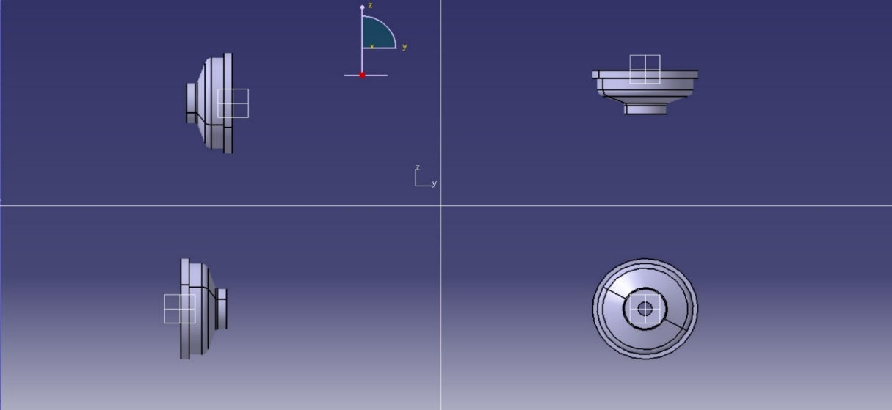

Figure 33

**9.1.3 CNC Program for Turning**

N5; WNO 49109863;  
N10; DRG N0 9B61M.253_01;  
N15; N0 MSG ("REFERENCE");  
N20; TOOL C;  
  
N25; T10 D1;  
N30; G0 G54 G94 X100 Z50;  
N35; G01 X40 Z0.5 F3000;  
N40; R2=2;  
N45; M0;  
  
N50; N1 MSG ("ROUGH TURNING");  
N55; TOOL C;  
N60; T10 D1;  
N65; G95 G0 G54 G90 X60 Z50;  
N70; LIMS=1000;  
N75; G96 S150 M4;  
N80: G01 X53 20.1 F5;  
N85; G01 X-0.8 F0.3;  
N90: G01 X55 Z5 M8;  
  
N95; CYCLE START;  
N100; CYCLE 95 (CSPO709-1-TURN);  
N105; G0 X75 Z50;  
N110; TOOL C;

N115; M01;  
N120; N02 MSG ("CENTER DRILLS”);  
N125; TOOL C;  
N130; T5 D1;  
N135; G0 G54 G95 X50 Z50;  
  
N140; G97 SI000 M3;  
N145; G01 X0 Z3 F2 M8;  
N150; Z-5 F0.05;  
N155; G0 Z50;  
N160; TOOL C;  
N165; M01;  
  
N170; N3 MSG (DS.5 DRILL”);  
NI75; TOOL C;  
N180; T2 D1;  
N185; G0 G54 G95 X50 Z250;  
N190; G97 X0 Z5 F5 M8;  
N195; F0.05;  
  
N200; CYCLE START  
N205; CYCLE 83E (2,-19,-5,30,1,1);  
N210; G0 Z250 M9;  
N215; TOOL C;  
N220; M01;  
N225; N4 MSG ("D25 FLAT/SLOT DRILL”);  
N230; TOOL C;  
N235; T12 D1;  
N240; G0 G54 G95 X50 Z50;  
N245; G97 S500 M3;  
N250; G01 X0 Z2 F5 M8;  
N255; G01 Z-6.8 F0.05;  
N260, G04 F1;  
N265; G0 Z250;  
N270; TOOL C;  
N275; M01;  
  
N280; N5 MSG ("ROUGH UNDER CUT");  
N285; USE 3MM PARTING TOOL;  
N290; TOOL;  
  
N295; T7 D1;  
N300; G0 G54 X100 Z50;  
N305; LIMS=800;  
N310; G96 S125 M4;  
  
N315; G01 X42 Z-6.6 F5 M8;  
N320; X34.2 F0.035;  
N325; X42 F2;  
N330; Z-9.4;  
N335; X34.2 F0.035;  
N340; X42 F2;  
N345; Z-9.4;  
N350; X34.2 F0.035;  
N355; X 42 F2;  
N360, Z-12.4;  
N365; X34.2 F0.035;  
N370; X42 F2;  
N 375; Z-14.7;  
N380; X16.5 F0.035;  
N385; X42 F2;  
N390; Z-16.7;  
N395; X16.5 F0.035  
N400; X36 F1;  
  
N405; Z-11.7;  
N410; X16.5 Z-14.F F0.035;  
N415; X50 F2;  
N420; G0 X100 VS M9;  
N425; X50 F2;  
  
N430; G0 X100 Z50 M9;  
N435; TOOL;  
  
N440; M01;  
N445; N6 MSG ("FINISH TURN");  
N450; TOOL C;  
N455; T8 D1;  
N460; G95 G0 G54 G90 X100 Z50;  
N465; LIMS=800;  
N470; G96 S150 M4;  
N475; G01 G42 X29 Z3 F5 M8;  
N480; Z0 F0.05;  
N485; X40 CHR=0.2;  
N490; Z-5;  
N495; X45;  
N500; G0 X100 Z50 M9;  
N505; TOOL C;  
N510; M01;  
  
N515; N7 MSG ("FINISH UNDER CUT");  
N520; USE 5.2MM GROOVING TOOL;  
N525; TOOL C;  
N530; T9 D1;  
N535; G0 G54 X100 Z50;  
N540; LIMS=800;  
N545; G96 S125 M4;  
N550; G01 X42 Z-8.4 F5 M8;  
  
N555; X33.7 F0.02 G09;  
N560; Z-12.75 RND=2.9 F0.05;  
N565; X15.93 Z-15.93 RND=0.5 F0.03;  
N570; G01 Z-16.5;  
N575; X55 F5;  
N580; G0 X100 Z50;  
N585; TOOL C;  
N590; M01;  
  
N595; N8 MSG (“ROUGH BORE”);  
N600; TOOL C;  
N605; T4 D1;  
N610; G0 G54 G95 X50 Z5O;  
N615; G97 X14 Z5 F5 M8;  
N620; Z-6.5 F2;  
N625; Z-7 FO.1;  
N630; X5;  
N635; X14 Z-6.5 F1;  
N640; Z-7.2 F0.1;  
N645; X5;  
N650; X14 Z-6.5 F1;  
N655; Z-7.35 F0.L;  
N660; X5;  
N665; X14 Z-6.5 F1;  
N670; Z-7.45 F0.1;  
N675; X5;  
  
N680; G01 X14.5 Z3 F2;  
  
N685; CYCLE START:-  
N690; CYCLE 95 (CSPO 709-2-BORE);  
N695; G0 Z50 M9;  
N700; TOOL C;  
N705; M01;  
  
N710; N9 MSG ("FINISH BORE");  
N715; TOOL C;  
N720; T4 D1;  
N725; G0 G54 G95 X50 Z30;  
N730; G97 S800 M3;  
N735; G01 G41 X33.075 Z2 F5 M8;  
  
N740; Z0.7 F0.05;  
N745; X31.075 Z-0.3;  
N750; Z-6.893 RND=1;  
N755; X 15.25 Z-7.55 F0.03;  
N760; X5 F0.05  
N765; G0 Z50;  
N770; TOOL C;  
  
N775; M01;  
N780; N10 MSG ("COUNTER SINK");  
N785; TOOL C;  
N790; T6 D1;  
N795; G0 G54 X20 Z50;  
N800; G95 S600 M3;  
  
N805; G01 X0 Z5 F4;  
N810; Z-6 F0.5;  
N815; Z-10.51 F0.03;  
N820; Z5 F3;  
N825; G0 Z10;  
N830; TOOL C;  
N835; M01;  
N840; N11 MSG ("PARTING");  
N845; TOOL C;  
N850; T7 D1;  
N855: G95 G0 G54 G90 X100 Z50;  
N860: LIMS-800;  
N865: G96 S120 M4;  
N870; G01 X53 Z-16.5 F7;  
N875; X 16.5 F0.5  
N880; X6.5 F0.03;  
N885; G04 F5 M9;  
N890; X4 F0.01;  
N895; X75 F2;  
N900; G0 Z50 M9;  
N905, TOOL C;  
N910; M01;

**9.2 DRILLING**

**9.2.1 CNC Drilling Machine Specifications:**

* **Make** HARDINGE VMC 1250
* **Type** CNC VERTICAL MACHININGCENTER
* **Axis** 4-Axis; X-1250; Y-660; Z-635; A-360
* **Control system** SINUMERIC 810D
* **Memory capacity**  2.048MB
* **Automatic tool changer** 20 (max capacity)
* **Machine code** 65005
* **Machine cost** 72.18Lakhs
* **Cycle type** 1.02 minutes

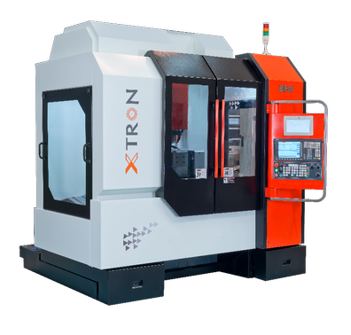

Figure 34

**9.2.2 SEQUENCE OF OPERATIONS FOR DRILLING**

* **Deep hole drill**

**-**Use Diameter 2.0mm twist drill (4 holes)

**9.2.3 CNC Program for drilling**

N5; Project-KONKURS-M

N10; Component name: - Cover

N15; Material and Specifications: - Forged blank for cam

N20; 20CR13 T0 IS6603

N25; Diameter: - 205mm (WORK OFFSET)

N30; 11 G5 (Deep Drill hole)

N35; Diameter 2.0mm F80 mm/min S2000 revolutions

N40; Z1= -2;

N45; Position: - Z0=3.2;

N50; X0=9.46;

N55; Y0=15.14;

N60; Y1= -15.14;

N65; G0 G90 G55 Z200;

N70; G53 Y0;

N75; PROGRAM END

**9.3 MILLING**

**9.3.1 CNC Milling Machine Specifications:**

* **Make** TAJMAC ZPS MCV 1210
* **Type** CNC Vertical machining center
* **Machine code** 65006
* **Axis**  5axis; X-1200; Y-800; Z-600; A-795
* **Control system** SINUMERIC 840D
* **Memory capacity** 11MB
* **Automatic tool changer capacity** 60
* **Machine cost** 2.34crores
* **Cycle time** 8.55 minutes

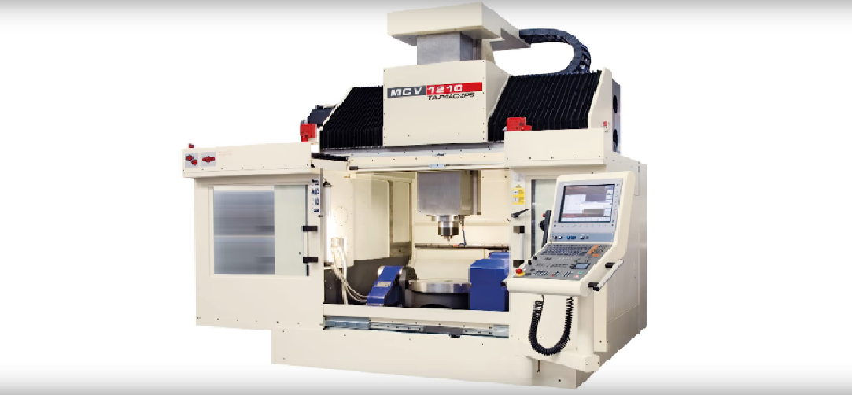

Figure 35

**9.3.2 FIXTURE FOR MILLING OPERATION**

A special fixture is used to mount the work piece on the machine, after completing the drilling operation the holes are used as reference for the milling operation. The work piece is aligned correctly, and an Allen bolt is used to hold the work in place.

**9.3.3 SEQUENCE OF OPERATIONS FOR MILLING**

* **Path milling**

**-**Use Diameter 12mm End mill, F300mm/min, S3000 revs

* **Centre drill**

-For locating the holes, S3000 revs

* **Deep hole drilling**

**-**Use Diameter 2mm twist drill, F 50mm/min, S3000 revs

* **Deep hole drilling**

-Use Diameter 1.2mm twist drill, F 50mm/min, S 2500 rev

* **Counter sinking**

-Use Diameter 1mm counter sink tool

**9.3.4 CNC Program for Milling**

N05; 01021 (COVER 9MB61M253);

N10; G53 G0 U270.0 (TURRET CLEARANCE);

N15; M370 (TURRET TO CLEAR ORIENT);

N20; N10 (PROFILE MILL EM10);

N25; G806 G54 T21 Y200 Z2500 X-25.0 A0.0 B90.0 S2200 F200;

N30; G01 Z-13.4 F250 M8;

N35; G01 G42 Y12.8 X-16.98 F100;

N40; Y-10.23;

N45; G03 X-16.41 Y-11.2 R1.0;

N50; G01 Y-15.47 X-8.7;

N55; G03 Y-17.45 X8.07 R17.45;

N60; G03 Y-15.47 X8.07 R17.45;

N65; G01 Y-11.12 X16.41;

N70; G03 X16.41 Y11.12 R1.0;

N75; G01 Y10.23;

N80; G03 X16.41 Y11.12 R1.0;

N85; G01 X8.07 Y15.47;

N90; G03 X-8.07 Y15.47 R17.45;

N95; G01 X-16.41 Y11.12;

N100; G03 X-17.0 Y10.23 R1.0;

N101; G01 Y-15.0 F200;

N110; G0 G40 X-45.0;

N115; Y31.0;

N120; G0 Z-10.2;

N125; X-10.0;

N130; G01 G42 X-4.2 Y26.0 F90;

N135; Y10.2 G02 Y4.2 X-10.2 R5.8;

N140; G01 X-21.0;

N145; G01 Y-4.2 F300;

N150; G01 X-10.2 F90;

N155; G02 X-4.2 Y-10.2 R5.8;

N160; G01 Y21.0;

N165; G01 Y4.2 F300;

N170; G01 X10.2 R5.8;

N175; G01 Y26.2;

N180; G01 X-4.0 F300;

N180; G01 Y10.0 F200;

N190; G02 Y4.0 X-10.0 R6.0;

N195; G01 X-21.0;

N200; G01 Y-4.0 F300;

N205; G01 X-10.0 F200;

N210; G02 X-4.0 Y-10.0 R6.0;

N215; G01 Y-21.0;

N220; G01 X4.0 F300;

N225; Y-10.0 F200;

N230; G02 X10.0 Y-4.0 R6.0;

N235; G01 X21.0;

N240; G01 Y4.0 F300;

N245; G01 X10.0 F200;

N250; G02 X4.0 Y10.0 R6.0;

N255; G01Y26.0;

N260; G01 Y30.0 F200;

N265; G0 G40 X-40.0;

N270; Z10.0 M9;

N275; N20 (CD DIAMETER2.0);

N280; G806 G54 T22 Y-2.0 X-12.0 Z7.0 A0.0 B69.0 S3000 F200;

N285; G81 R7.0 Z-0.05 G98 M8;

N290; Y2.0;

N295; A90;

N300; Y-2.0;

N305; A180;

N310; Y2.0;

N315; A270;

N320; Y-2.0;

N325; G0 G80 Z80 M9;

N330; N30 (CENTER DRILL 4M);

N335; G806 G54 T11 Y-2.0 X-12.0 Z7.0 A0.0 B69.0 S 3000 F150;

N340; G83 R7.0 Q0.5 Z-3.0 G98 M8;

N345; Y2.0;

N50; A90;

N355; Y-2.0;

N360; A270;

N365; Y-2.0;

N370; G0 G80 Z80 M9;

N375; M6 T0;

N380; G53 Z-30 Y-30 Z-30;

N385; G54 G0 A0;

N390; M30;

N95; PROGRAM END

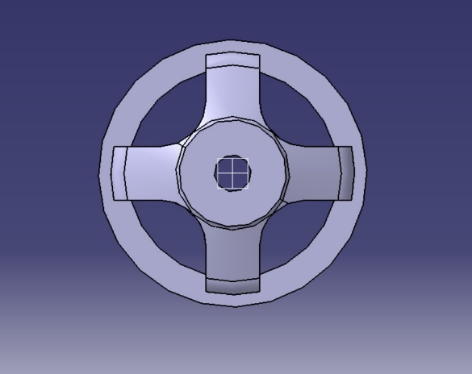

Figure 36: INITIAL COMPONENT

Figure 37:AFTER TURNING AND MILLING

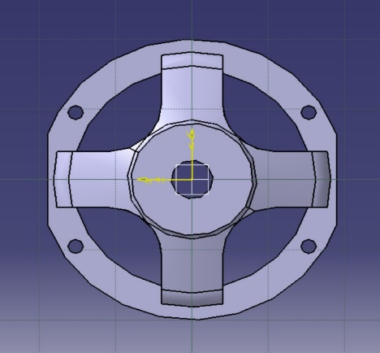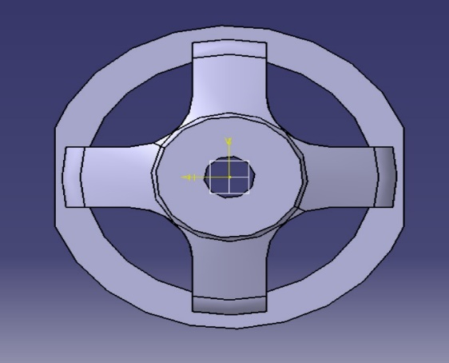

Figure 38:AFTER DRILLING

Figure 39:AFTER A LITTLE BIT OF MACHINING

Figure 40:FINAL COMPONENT

**10. DECLARATION**

We hereby declare that the project entitled **“CODING CNC KONKURS-M MISSILE COMPONENT (COVER)”** submitted to **VIGNANA BHARATHI INSTITUTE OF TECHNOLOGY**, Ghatkesar is a record of an original work done by my group under the guidance of **Mr. JAYARAJU**. Of, BDL, Kanchan Bagh. This project is submitted in the partial fulfillment of the degree of Bachelor of Technology in mechanical engineering. The results embody in these have not been submitted to any other University or Institution for the award of any degree or diploma.

**12. CONCLUSION**

Development of **CNC** is technology is an outstanding contribution to the manufacturing industries. It has made possible the automation of the machining process with flexibility to handle small to medium batch quantities in part production. **CNC** program has been generated and executed for the manufacturing of the **KONKUR-M** missile cover (component) in three different CNC machines. The component is producing in three different machines like Turning, Drilling and Milling. we have used Turnmill machine to increase the flexibility and to increase the productivity by meeting all directions required as per the drawings given.